Contents
Area Model 1
Bar Model* 2
Decimal Grid 2
Fraction Bar 3
Fraction Models – Circles and Squares 3
Fraction Strips 4
Hundred Chart* 4
Grouping Tiles 5
Number Line* 5
Open Number Line* 6

*
Used in Base Ten

Area Model
A two-dimensional rectangle used to show that two-digit numbers can be split into smaller components which are smaller/more familiar and therefore easier to multiply.
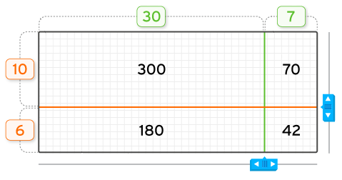

Bar Model
The Bar Model helps students graphically represent the known information in a contextualized problem so that they can use the pictured relationships to solve the problem.

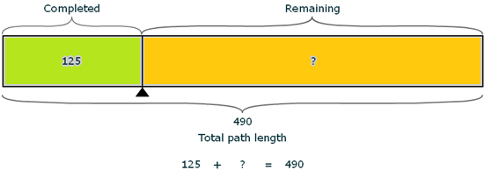

Decimal Grid
A 10 x 10 grid showing the numbers 1 through 100. Students can click on squares or enter in numbers in blank squares to highlight patterns.

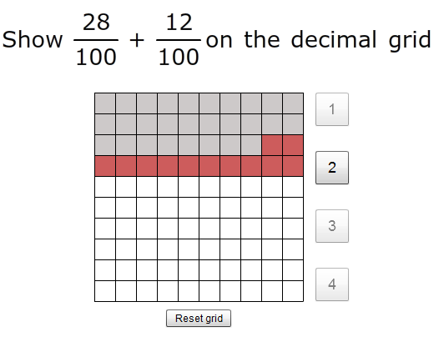

Fraction Bar
The Fraction Bar always shows equal parts of a whole. The student can choose a denominator and a numerator to see the resulting fraction. The student can use this visual tool to compare fractions.

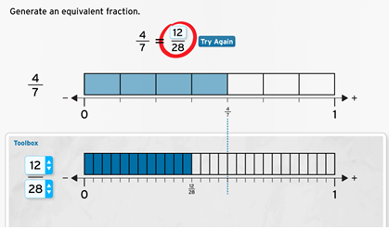

Fraction Models – Circles and Squares
The circle and square fraction models are area or region models that help students build an understanding of fractions as equal parts of a whole.

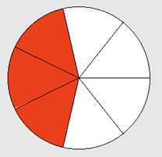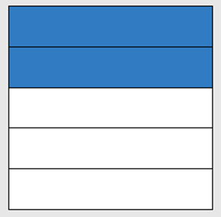

Fraction Strips
The Fraction Strips provide students with a pool of available fractions that they can click and drag into containers.

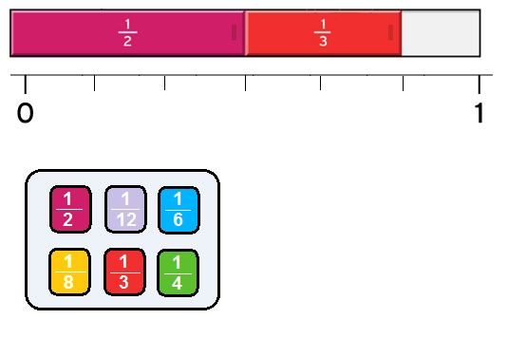

Hundred Chart
A 10 x 10 grid showing the numbers 1 through 100. Students can click on squares or enter in numbers in blank squares to highlight patterns.

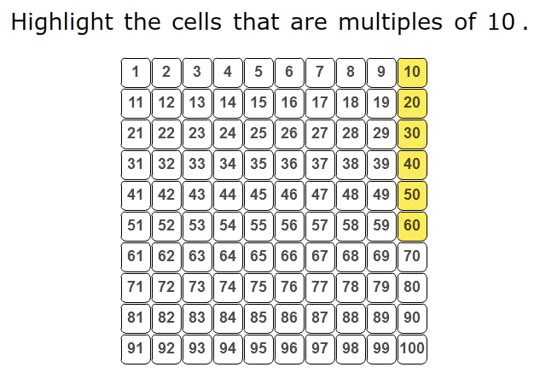

Grouping Tiles
Grouping tiles will be used to show multiplication by allowing students to click and drag square tiles into rows and columns.

Use the tiles to show 2 x 3.
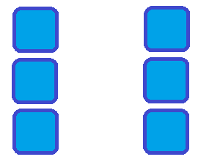

Number Line
A vertical or horizontal open-ended line used with rational numbers (integers, fractions, decimals) and displayed with even tick marks. Labels can be placed anywhere and can be either numbers or words.
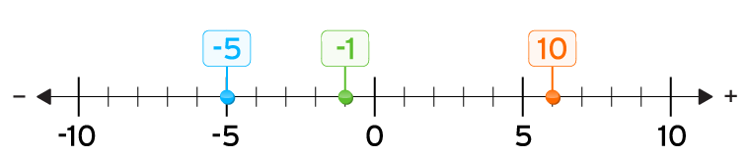

Open Number Line
A vertical or horizontal open-ended line used with rational numbers (integers, fractions, decimals) and displayed with little to no tick marks. Students can identify where on the number line the relevant numbers go by dragging them in from a number pool. Additionally they can fill in boxes to calculate distance between jumps. This is used as a more abstract form of the Number Line since students won’t be able to simply count tick marks.

10 – (-5)

